“Education Through Self Help”
Rayat Shikshan Sanstha’s
Arts, Science and Commerce College
A/P:-Mokhada ,Tal:- Mokhada,Dist:-Palghar -401604
Phone No: - (02529)256628, Fax: (02529)256628
E-mail:- asccmokhada@gmail.com
Website: - www.asccmokhada.com

Annual Quality Assurance Report (AQAR)
of Internal Quality Assurance Cell (IQAC)
of the Institutions for the year 2016-17
Submitted to
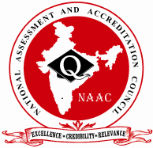
NATIONAL ASSESSMENT AND ACCREDITATION COUNCIL
An Autonomous Institution of the University Grants Commission
P. O. Box. No. 1075, Opp: NLSIU, Nagarbhavi, Bangalore - 560 072 India

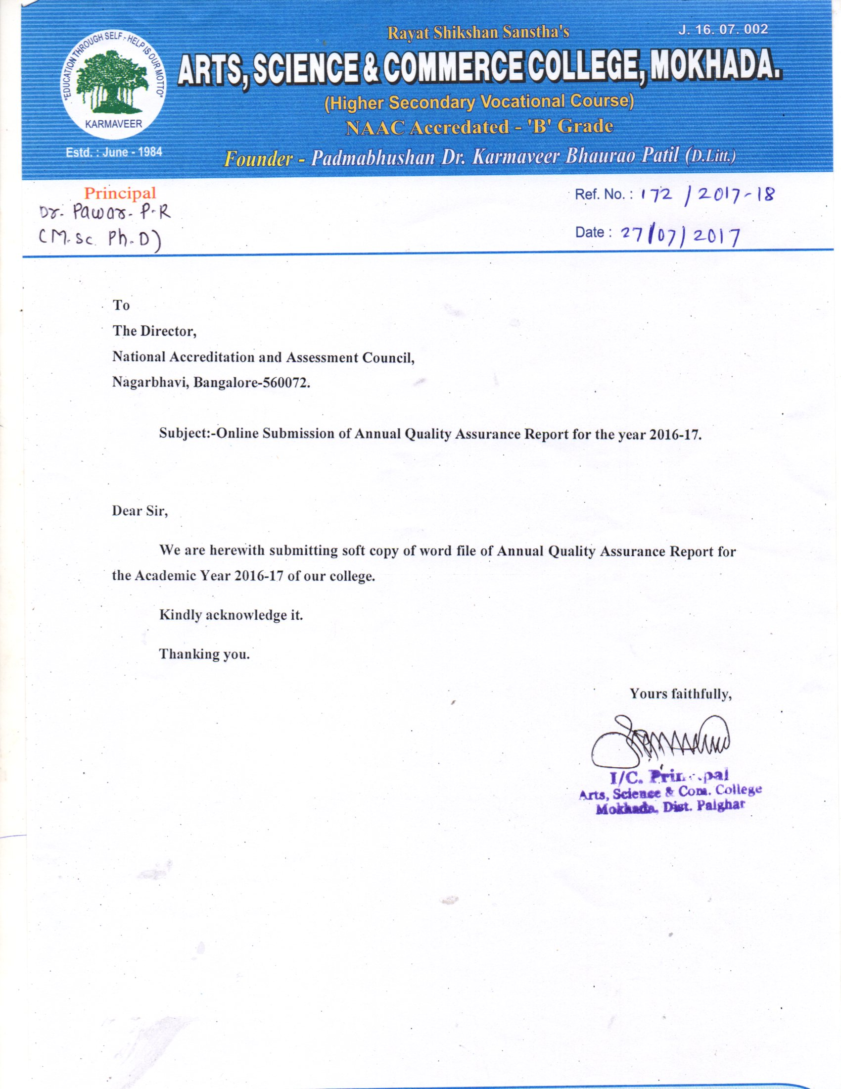

Contents

Sr. No. | Particulars | Page No.
PART- A
1 | Details of the Institution | 4 -8
2 | IQAC Composition and Activities | 9-10
PART- B
3 | Criterion- I: Curriculum Aspects | 11-13
4 | Criterion- II: Teaching, Learning and Evaluation | 14-17
5 | Criterion- III: Research, Consultancy and Extension | 18-22
6 | Criterion- IV: Infrastructure and Learning Resources | 23-25
7 | Criterion- V: Student Support and Progression | 26-30
8 | Criterion-VI: Governance, Leadership & Management | 31-37
9 | Criterion-VII: Innovations and Best Practices | 38-40
Annexure

i | Academic Calendar (2016-17) | 41-44
ii | Best practice–I | 45
iii | Best practice-II | 46

Part-A

Institution Details

The Annual Quality Assurance Report (AQAR) of the IQAC

Part – A
2016-17
AQAR for the year

1.Details of the Institution
Rayat Shikshan Sanstha’s
Arts, Science & Commerce College, Mokhada Dist.Palghar
1.1 Name of the Institution

A/p:-Mokhada
Tal:-Mokhada
1.2 Address Line 1
Tal:-Mokhada
Address Line 2
Palghar
City/Town
Maharashtra
State
401604
Pin Code
asccmokhada@gmail.com
Institution e-mail address
(02529)256628
Contact Nos.

Name of the Head of the Institution:
Dr.Pawar P.R.
(02529)256628
Fax:
9869616135
Mobile:

Name of the IQAC Co-ordinator:
Asst. Prof. Bhave A. V.
7030457595
Mobile:
asccmokhada@gmail.com

IQAC e-mail address:
MHCOGN 15158
1.3 NAAC Track ID(For ex. MHCOGN 18879)
OR
16th – 18th Dec. 2013
1.4 NAAC Executive Committee No. &Date:
(For Example EC/32/A&A/143 dated 3-5-2004.
This EC no.is available in the right corner-bottom
of your institution’s Accreditation Certificate)
www.asccmokhada.com
1.5Website address:
www.asccmokhada.com/downloads/AQAR2016-17
Web-link of the AQAR:

1.6Accreditation Details
Sl.No. | Cycle | Grade | CGPA | Year of Accreditation | Validity Period
1 | 1st Cycle | B | 2.21 | 2014 | 2019
2 | 2nd Cycle
3 | 3rd Cycle
4 | 4th Cycle

15/01/2009
1.7Date of Establishment of IQAC: DD/MM/YYYY

1.8 Details of the previous year’s AQAR submitted to NAACafterthe latest Assessment and
Accreditation by NAAC

AQAR 2014-15 submitted to NAAC on 22-06-2015
AQAR 2015-16 submitted to NAAC on 19-07-2016

1.9Institutional Status

University State CentralDeemedPrivate Affiliated

College Yes No
Constituent College Yes No

Autonomous collegeof UGC Yes No

Regulatory Agency approved Institution Yes No
(eg. AICTE, BCI, MCI, PCI, NCI)

Type of Institution Co-education Men Women

Urban Rural Tribal

Financial Status Grant-in-aid UGC 2(f) UGC 12B

Grant-in-aid +Self FinancingTotally Self-financing

1.10Type of Faculty/Programme

Arts Science Commerce Law PEI(Phys Edu)

TEI (Edu) Engineering Health Science Management

Others (Specify)
University of Mumbai
1.11Name of the Affiliating University (for the Colleges)

1.12 Special status conferred by Central/ State Government-- UGC/CSIR/DST/DBT/ICMR etc
Autonomy by State/Central Govt. / University
No
University with Potential for Excellence UGC-CPE
No

No

DST Star Scheme UGC-CE
No

No

No

No

UGC-Special Assistance Programme DST-FIST
No

No

UGC-Innovative PG programmes Any other (Specify)
No
UGC-COP Programmes

2.IQACComposition and Activities
04
2.1No. of Teachers
01
2.2No. of Administrative/Technical staff
01
2.3No. of students
2.4No. of Management representatives
02
02
2.5No. of Alumni
2. 6 No. of any other stakeholder and
00
community representatives
00
2.7 No. of Employers/ Industrialists
00
2.8 No. of other External Experts
10
2.9 Total No. of members
2.10 No. of IQAC meetings held 02
03
07
2.11 No. of meetings with various stakeholders: No. Faculty
01
01
02
Non-Teaching Staff Students Alumni Others

2.12Has IQAC received any funding from UGC during the year? Yes No

If yes, mention the amount

2.13Seminars and Conferences (only quality related)
(i) No. of Seminars/Conferences/ Workshops/Symposia organized by the IQAC
1
0
0
0
000
Total Nos. International National State Institution Level
1. Women Empowerment

(ii) Themes
2.14Significant Activities and contributions made by IQAC
1. Conducted meetings of IQAC regularly.
2. Participation by teachers in Seminars, Workshops, Conferences.
3. Encouraged teachers for research work.
4. Provided statistical data to HRD Ministry, State Govt., NIRF, UGC and University of .
Mumbai as and when required.

2.15 Plan of Action by IQAC/Outcome
The plan of action chalked out by the IQAC in the beginning of the year towards quality
enhancement and the outcome achieved by the end of the year.
Plan of Action | Achievements
1.IQAC meetings.  2. Examination.  3. Extracurricular activities under  NSS, Cultural Activities and  Sports Activities.  4.Organisation of Guest Lectures  5.Work by Administrative committees | 1. Helped for successfully conducting college  activities.  2.ConductedFirst and Second Year Examinations  regularly and declared Results on time.  3. Created social awareness among students.  Achieved improvement in personality  development and physical fitness of the  students.  4.Benefited students by increasing their  knowledge in various subjects.  5.Achieved smooth functioning of college  administration.
Note: - Attached Academic Calendar of the Academic Year 2015-16 as Annexure I.
2.15Whether the AQAR was placed instatutory body Yes No

LMC

Management Syndicate Any other body
Provide the details of the action taken
1. Smooth functioning of college administration.
2. Discipline.

Part-B

CRITERION – I
CURRICULUM ASPECTS

Part – B
Criterion – I

- Curriculum Aspects

1.1 Details about Academic Programmes
Level of the Programme | Number of existing Programmes | Number of programmes added during the year | Number of self-financing programmes | Number of value added / Career Oriented programmes
PG | 1 | 0 | 1 | 0
UG | 3 | 0 | 0 | 0
PG Diploma | 0 | 0 | 0 | 0
Advanced Diploma | 0 | 0 | 0 | 0
Diploma | 0 | 0 | 0 | 0
Certificate | 0 | 2 | 0 | 2
Others | 0 | 0 | 0 | 0
Total | 4 | 2 | 1 | 2

Interdisciplinary | 0 | 0 | 0 | 0
Innovative | 0 | 0 | 0 | 0

  - (i) Flexibility of the Curriculum: CBCS/Core/Elective option / Open options
Programme | Options
T.Y. B.A. | 1.History(Six Papers)  2.History and Economics(Three Papers each)  3.History and Marathi(Three Papers each)
T.Y.B.Sc. | 1.Mathematics  2.Physics  3.Chemistry  4.Botany  5.Zoology

(ii) Pattern of programmes:
Pattern | Number of programmes
Semester | 04
Trimester | 00
Annual | 00

1.3Feedback from stakeholders*Alumni Parents EmployersStudents
(On all aspects)
No

Noo
Mode of feedback:Online ManualCo-operating schools (for PEI)

1.4 Whether there is any revision/update of regulation or syllabi, if yes, mention their salient aspects.
During the Academic Year syllabus is revised for First YearB.A.,B.Com. and B.Sc. as per semester pattern by respective Boards of Studies of Mumbai University.

1.5 Any new Department/Centre introduced during the year. If yes, give details.
No

CRITERION – II
TEACHING,
LEARNING
& EVALUATION

Criterion – II
- Teaching, Learning and Evaluation

Total | Asst. Professors | Associate Professors | Professors | Others
08 | 07 | 01 | 0 | 0
2.1 Total No. of
permanent faculty
2.2 No. of permanent faculty with Ph.D.
01
Asst. Professors |  | Associate Professors |  | Professors |  | Others |  | Total
R | V | R | V | R | V | R | V | R | V
0 | 10 | 0 | 0 | 0 | 1 | 0 | 0 | 0 | 0
2.3 No. of Faculty Positions
Recruited (R) and Vacant
(V) during the year
08
00
00
2.4 No. of Guest and Visiting faculty and Temporary faculty
2.5Faculty participation in conferences and symposia:

No. of Faculty | International level | National level | State level
Attended Seminars Workshops | 05 | 04 | 02
Presented papers | 05 | 04 | 00
Resource Persons | 00 | 00 | 00

2.6Innovative processes adopted by the institution in Teaching and Learning:
1. Encouraged teachers for the improvement of teaching-learning process.
2. Evaluation of teachers and students after taking into consideration performance of the students
in internal evaluation and semester examinations.
3. Conducted remedial coaching classes.
4. Promoted the research and extension activities among the faculty members and students.
5.Motivated teachers to participate in seminar, conference, workshop etc. to update their
knowledge and for the use of new technology.
6. Arranged study tours and field visits.
7. Used internet for online study.
8. Organized Exhibition of new books for students.

2.7Total No. of actual teaching days
184
during this academic year
2.8Examination/ Evaluation Reforms initiated by
Photocopy,
Double Valuation, Moderation
the Institution(for example: Open Book Examination,Bar Coding,
Double Valuation, Photocopy, Online MultipleChoice Questions)

2.9No. of faculty members involved in curriculum
01
00
00
Restructuring/revision/syllabus development
as member of Board of Study/Faculty/Curriculum
Development Workshop
81.33%
2.10 Average percentage of attendance of students

2.11 Course/Programme wise distribution of pass percentage:

Title of the Programme | Total no. of students appeared | Grades
 |  | O | A | B | C | D | E | Pass %
F.Y.B.A. Sem I | 113 | -- | -- | 05 | 15 | 11 | -- | 27.43%
F.Y.B.A. Sem II | 106 | -- | -- | 01 | 24 | 21 | -- | 43.39%
S.Y.B.A. Sem III | 97 | -- | 04 | 25 | 22 | 17 | 01 | 71.13%
S.Y.B.A. Sem IV | 93 | -- | 10 | 26 | 31 | 12 | 02 | 87.09%
T.Y.B.A. Sem V | 77 | 01 | 12 | 13 | 23 | 12 | -- | 79.22%
T.Y.B.A. Sem VI | Yet Not Declared
F.Y.B.Com Sem I | 44 | -- | 02 | 04 | 02 | -- | -- | 18.18%
F.Y.B.Com Sem II | 40 | -- | 05 | 13 | 06 | -- | -- | 60.00%
S.Y.B.Com Sem III | 32 | 02 | 12 | 07 | 03 | -- | -- | 96.87%
S.Y.B.Com Sem IV | 31 | 01 | 12 | 05 | 01 | -- | -- | 100.0%
T.Y.B.Com Sem V | 39 | 00 | 04 | 15 | 13 | 06 | 01 | 89.75%
T.Y.B.Com Sem VI | Yet Not Declared
F. Y. B. Sc .Sem I | 68 | -- | 01 | 20 | 16 | 01 | -- | 55.88%
F. Y. B. Sc .Sem II | 68 | -- | 03 | 22 | 19 | -- | -- | 64.70%
S. Y. B. Sc. Sem III | 35 | 01 | 05 | 07 | 08 | 02 | -- | 65.71%
S. Y. B. Sc. Sem IV | 34 | 01 | 15 | 12 | 03 | -- | -- | 91.17%
T. Y.B. Sc. Sem V | 32 | --- | 15 | 10 | 2 | -- | -- | 84.37%
T. Y .B. Sc. Sem VI | Yet Not Declared
M.A.I Sem I | 30 | 00 | 02 | 11 | 01 | 00 | 00 | 46.66%
M.A.I Sem II | Yet Not Declared
M.A.II Sem III | 21 | 01 | 05 | 07 | 04 | 00 | 00 | 80.95%
M.A.II Sem IV | Yet Not Declared

2.12How does IQAC Contribute/Monitor/Evaluate the Teaching & Learning processes:-
IQAC:-
1]Arranges workshop for staff and students for quality teaching and learning, use of Library facility, use
of modern ICT in teaching and learning.
2] Takes Feedback from students and parents, analyses feedback and arranges discussions on it in staff
meetings.

2.13Initiativesundertaken towards faculty development
Faculty / Staff Development Programmes | Number of faculty  benefitted
Refresher courses | 01
UGC – Faculty Improvement Programme | 00
HRD programmes | 00
Orientation programmes | 00
Faculty exchange programme | 00
Staff training conducted by the university | 00
Staff training conducted by other institutions | 00
Summer / Winter schools, Workshops, etc. | 00
Others | 00
2.14Details of Administrative and Technical staff
Category | Number of Permanent  Employees | Number of  Vacant Positions | Number of permanent positions filled during the Year | Number of positions filled temporarily
Administrative Staff | 03 | 00 | 00 | 00
Technical Staff | 00 | 00 | 00 | 00

CRITERION – III
RESEARCH,
CONSULTANCY
AND
EXTENSION

Criterion – III
3.Research, Consultancy and Extension
3.1 Initiatives of the IQAC in Sensitizing/Promoting Research Climate in the institution
1. Encouraged faculty members to take on Minor and Major Research Projects of UGC and the
University of Mumbai.
2. Encouraged faculty members to carry on the research for Ph.D.
3. Motivated faculty members to participate in national and international seminars /workshops and
training programs.
4. Developed research culture in the college.
5. Encouragedfaculty members for writing research papers and presentation.
6. Arranged lectures under staff academy on research topics.

3.2Details regarding major projects
 | Completed | Ongoing | Sanctioned | Submitted
Number | 00 | 00 | 00 | 00
Outlay in Rs. Lakhs | 00 | 00 | 00 | 00

3.3Details regarding minor projects
 | Completed | Ongoing | Sanctioned | Submitted
Number | 00 | 00 | 00 | 00
Outlay in Rs. Lakhs | 00 | 00 | 00 | 00

3.4Details on research publications
Particulars | International | National | Others
Peer Review Journals | 2 | 1 | -
Non-Peer Review Journals | - | - | -
e-Journals | 1 | - | -
Conference proceedings | 1 | 2 | -

3.5 Details on Impact factor of publications:

Range Average h-index Nos. in SCOPUS

3.6 Research funds sanctioned and received from various funding agencies, industry and other organisations
Nature of the Project | Duration  Year | Name of the  funding Agency | Total grant  sanctioned | Received
Major projects | 00 | - | 00 | 00
Minor Projects | 00 | - | 00 | 00
Interdisciplinary Projects | 00 | - | 00 | 00
Industry sponsored | 00 | - | 00 | 00
Projects sponsored by the University/ College | 00 | - | 00 | 00
Students research projects | 00 | - | 00 | 00
Any other(Specify) | 00 | - | 00 | 00
Total | 00 | - | 00 | 00
00
3.7 No. of books published i) With ISBN No.Chapters in Edited Books
00
00
ii) Without ISBN No.

3.8 No. of University Departments receiving funds from
00
UGC-SAP CAS DST-FIST
00

00

00

00

DPE DBT Scheme/funds
3.9 For colleges Autonomy CPE DBT Star Scheme
00
00
00
INSPIRE CE Any Other (specify)
00
00
00

3.10 Revenue generated through consultancy: -Nil
3.11No. of conferences organized by the Institution: -01
3.12No. of faculty served as experts, chairpersons or resource persons:-00
00
00
00

00
3.13No. of collaborations
International National University Any other
3.14No. of linkages created during this year
00

3.15Total budget for research for current year in lakhs:-Nil
00
00
From Funding Agency From Management of University/College
Total
00
Type of Patent |  | Number
National | Applied | 00
 | Granted | 00
International | Applied | 00
 | Granted | 00
Commercialised | Applied | 00
 | Granted | 00

3.16No. of patents received this year

3.17No. of research awards/ recognitions received by faculty and research fellows of the institute
Total | International | National | State | University | District | College
00 | 00 | 00 | 00 | 00 | 00 | 00
in the year

3.18No. of faculty from the Institution
00
who are Ph.D. Guides
and students registered under them
00

3.19 No. of Ph.D. awarded by faculty from the Institution
00

3.20No. of Research scholars receiving the Fellowships (Newly enrolled + existing ones)
00
00
00
JRF SRF Project Fellows Any other
00

3.21No. of students Participated in NSS events:
00
00

University level State level
National level International level
00
00

3.22No.of students participated in NCC events:
00
00
University level State level
National level International level
00
00

3.23 No. of Awards won in NSS:
University level State level
00
00
National level International level
00
00

3.24 No. of Awards won in NCC:
University level State level
00
00
National level International level
00
00

3.25No. of Extension activities organized
00
00
University forum College forum
00
02
04
NCCNSSAny other

3.26 Major Activities during the year in the sphere of extension activities and Institutional Social
Responsibility
1. Yoga Camp.
2. Disaster Management.
3. Blood donation camp.
4. Voters awareness rally.
5. Sampurna Swachchata Abhiyan (Total Cleanliness Programme).
6. Health Check Up Camp for Students.

CRITERION – IV
INFRASTRUCTURE
AND LEARNING
RESOURCES

Criterion – IV
- Infrastructure and Learning Resources
4.1 Details of increase in infrastructure facilities:
Facilities | Existing | Newly created | Source of Fund | Total
Campus area | 8.6 acres | - | - | 8.6 acres
Class rooms | 09 | - | - | 09
Laboratories | 04 | - | - | 04
Seminar Halls | 01 | - | - | 01
No. of important equipments purchased (≥ 1-0 lakh) during the current year. | - | - | - | -
Value of the equipment purchased during the year (Rs. in Lakhs) | - | 1.80944 | UGC | -
Others | - | - | - | -

4.2 Computerization of administration and library
1. Computerization of Administrative work regarding Admission, Scholarship, Examination and
other student related work.
2. Computerization of Accounts work by using the Tally software.
3. Use of Library Manager Software for registration and issue of books.
4. LAN sharing of Office, Library and Department Computers.
5. Biometric attendance.

4.3 Library services:
Particular- | Existing |  | Newly added |  | Total
 | No. | Value | No. | Value | No. | Value
Text Books | 6790 | 759410 | 305 | 33774 | 7095 | 793184
Reference Books | 8276 | 1188614 | 176 | 53516 | 8452 | 1242130
e-Books | - | - | - | - | - | -
Journals | 30 | 18000 | - | - | 30 | 1800
e-Journals | - | - | - | - | - | -
Digital Database
CD & Video | 53 | 15089 | - | - | 53 | 15089
Others (specify) | - | - | - | - | - | -

4.4Technology up gradation (overall)
Particulars | Total Computers | Computer Labs | Internet | Browsing Centres | Computer Centres | Office | Depart-ments | Others
Existing | 36 | 01 | 05 | - | - | 01 | 04 | 04
Added | 03 | - | - | - | - | 03 | - | -
Total | 39 | 01 | 05 | - | - | 04 | 04 | 04

4.5Computer, Internet access, training to teachers andstudents and any other programme for technology
up gradation (Networking, e-Governance etc.)
1. Computer facility and Internet access to all departments.
2. Internet access to all students through UGC Network Resource Centre.
3.Training to office staff for use of computers in administration work with new software.
4.Online accession of University papers.

4.6 Amount spent on maintenancein lakhs :- (Including New Purchase)
0.12400
i) ICT
0.48800
ii)Campus Infrastructure and facilities
1.51462
iii) Equipments
0.04179

iv) Others

Total :
2.16841

CRITERION – V
STUDENT SUPPORT
AND PROGRESSION

Criterion – V
- Student Support and Progression

5.1 Contribution of IQAC in enhancing awareness about Student Support Services
1. Gave printed prospectus at the time of admission.
2.Displayed notices on notice boards.
3. Organized workshop, training programmes, group discussion and presentations for students.
4. Conducted counseling to students for competitive examination, placements and subject
Difficulties.
5. Guided students for using study material and reference books.

5.2 Efforts made by the institution for tracking the progression
1.Regular class tests are conducted.
2. Engaged extra lectures for improvement in results.
3.Took feedback from students at the end of the academic year.
4. Maintainedrecord for placement of the students.
5. Organisedparents meetings.

UG | PG | Ph. D. | Others
563 | 46 | 00 | 00
5.3 (a) Total Number of students

(b) No. of students outside the state
00
00
(c) No. of international students
No | %
00 | -
No | %
00 | -
\
Men Women
Last Year  2015-16 |  |  |  |  | This Year  2016-17
General | SC | ST | OBC | Physically Challenged | General | SC | ST | OBC | Physically Challenged
05 | 25 | 485 | 51 | 00 | 09 | 22 | 524 | 54 | 00

8.33 %
1:0.46
Demand ratioDropout %

5.4Details of student support mechanism for coaching for competitive examinations (If any)
1. Organized lectures for students on competitive exam guidance.
2, Experts are invited from various fields.
3. Internet and Library resources are made available for the students.

29
No. of students beneficiaries

5.5 No. of students qualified in these examinations
00
00
00
00
NET SET/SLET GATE CAT
IAS/IPS etc State PSC UPSC Others
00
00
00
00

5.6 Details of student counselling and career guidance
1. Workshop, seminars, guest lecturers have been organized.
2. Arranged Personal counseling to students for pointing out their potentials.
3. Displayed advertisements of competitive exams on notice board.
4. Guided students on specific subjects of competitive exams.

No. of students benefitted: - 29

5.7Details of campus placement
Number of Organizations Visited | Number of Students Participated | Number of Students Placed | Number of Students Placed
00 | 00 | 00 | 00

5.8Details of gender sensitization programmes
1.Organised workshop on Women Empowerment on 20th December 2016.
2. Celebrated International Women’s Day.

5.9Students Activities
5.9.1 No. of students participated in Sports, Games and other events
00
00
01
State/ University levelNational levelInternational level

No. of students participated in cultural events
00
00
00
State/ University level National level International level

5.9.2 No. of medals /awards won by students in Sports, Games and other events
00
00
01
Sports: State/ University level National level International level
00
00
00
Cultural: State/ University level National level International level

5.10Scholarships and Financial Support
Particulars | Number of  students | Amount(In Rupees)
Financial support from institution | Nil | Nil
Financial support from government | 574 | 38,96,835
Financial support from other sources | 422 | 7,31,300
Number of students who received International/ National recognitions | Nil | Nil
5.11Student organised / initiatives
00
00
00
Fairs : State/ University level National level International level
00
00
00
Exhibition: State/ University level National level International level

03
5.12No. of social initiatives undertaken by the students

5.13 Major grievances of students (if any) redressed: -Nil

CRITERION – VI
GOVERNANCE,
LEADERSHIP AND
MANAGEMENT

Criterion – VI
- Governance, Leadership and Management

6.1 State the Vision and Mission of the institution
VISION
To generate academic, scientific temper, physical, spiritual, social and cultural values among the students and to make them responsible citizens of the world.
MISSION
To impart higher education to downtrodden, tribalswith multifaceted aspects, excelling the human resources in broader perspectives of national and global context.

6.2Does the Institution has a Management Information System
YES.
1. To manage administrative work efficiently, computerized programme, hardware and software
are used.
2. Display college events and important information through college website.
3. Important correspondence with University, UGC, HRD, State Government, Higher education
and other departments are made through E-mail facility.
4. Submission of Online Examination Forms for University Examination.
5. Submission of online scholarship, pre-admission and registration.

6.3Quality improvement strategies adoptedby the institution for each of the following:
6.3.1 Curriculum Development
The college is affiliated to University of Mumbai. Instructions of University are fallowed for Curriculum Development.
.

6.3.2 Teaching and Learning
1. Use of ICT.
2. Library resources.
3. UGC Network Resource Centre.
4.Language lab.
5. Deputation of students for participation in seminar, workshop, training programme organized
by University and other Institutions.

6.3.3 Examination and Evaluation
1. The college is affiliated to University of Mumbai and Examination and Evaluation pattern of
University of Mumbai has been followed.
2. At present, credit based grading system has been followed.

6.3.4 Research and Development
1. Allocation of UGC funds as per sanction by UGC.
2. Provide infrastructure for Minor and Major research Projects, Ph. D. and M. Phil .research
3. Institutional support for students for research field work.
4. Encourage research cultural amongst students through survey, questionnaire, discussion,
Interviews etc.

6.3.5 Library, ICT and physical infrastructure / instrumentation
Library

1. Provide Text books, Reference Books, Magazines, Journals to the students.
2. Book bank facility, Inter library loan facility is available to the staff and students.
3. Reading room facility is available for staff and students.
ICT

1. Language Lab.
2. Free internet service for students.
3. Reprography facility in the Library.
4. Online access to study material, CD’s,Videos and E-journals.

Physical infrastructure

1. Biometric System.
2. Display/ Notice Boards.
3. Clean water with Water Purifier.
4. Ventilated Classrooms.
Instrumentation

Refrigerator -02
Microscope-20
Steam generator water bath-02
Dual trace oscilloscope with digital output-01
Hot air oven-01
Incubator-01
Spectrophotometer-02
Colorimeter-04
pH meter-06
Conductometer-02
Potentiometer-02
Electronic weighing balance-01
Autoclave-01
Electrophoresis-01
Power supply-02
Electronic kits-02

6.3.6 Human Resource Management
1. Provision of Grievance Redressal Cell, BC Cell, Student Counseling Centre, Suggestion Box,
Assistance Cell, Discipline Committee, AntiRagging Cell, Women Cell, Health Centre,
Information Centre.
2. Recruitment of Teaching and Non-teaching staff as per sanction by University and State
Government.
3. Encouragement to staff for attending workshops, seminar, conferences atState, Nationaland
International level.
4. Fill up API forms of the faculty members at the end of every year.
5. Formation of various academic committees.
6. Encouragement to the faculty members for undertaking research projects.

6.3.7 Faculty and Staffrecruitment
Rayat Shikshan Sanstha, Satara recruit the best teachers who have passion in teaching. Recruitment of teachers is done strictly on the basis of the guidelines laid down by University Grants Commission, Maharashtra, State Government and University of Mumbai.

6.3.8 Industry Interaction / Collaboration
1. Inviting professional experts like CA, ICWA for guidance.
2. Inviting experts from different fields.

6.3.9 Admission of Students
1. Advertisement through handouts, physical visits to nearby educational institutes.
2. Printed admission prospectus with admission forms, I card forms with detailed profile of the
college before starting of new academic year.
3. Formation of Admission Committee, Help Desk.
4. Counselling to students for selection of subjects.
5. Display of admission circulars received from University, Govt. regarding reservation rules and
policies.
6. Followed admission process as per University schedule strictly.
7. Prepared a merit list on the basis of merit.
8. Transparency in admission process through display of merit list.

6.4Welfare schemes
Teaching and  Non teaching Staff | 1.Rayat Sevak cooperative Bank  There are various loan facilities made available to our employees by Rayat Sevak Co-operative Bank Ltd Satara and Laxmibai Bhaurao Patil Shikshanottejak Patpedhi.  Sr.No. Type of Loans  1 General loan  2 Emergency loan  3 Festival loan  4 Housing loan  5 Higher Purchase loan  6 Education Loan  2.Staff welfare committee :-  Various programmes are arrangedfor the welfare of the staff.  3.Staff-Academy :-  The faculty members from college as well as experts from other institutes deliver the lectures on interdisciplinary subjects. It enhances the knowledge of the faculty.  4.Women Empowerment Committee :-  The committee arranges the health awareness programmes and lectures creating legal awarenessamongthe girl students.  5.Sevak Welfare Fund:-  For the staff, Rayat Shikshan Sanstha ,Satara runs SevakWelfare Fundscheme.
Students | 1. SC/ST/OBC Welfare Cell, students counseling and grievance redressal cell.  2. Group insurance. Health Centre, Recreational and sports facilities.  3.Scholarship to all reserve category candidates byCentral, State Government,  University, HPCL.  4.Transport facility through State Transport by providingdocumentsfor  concession.  5. Book bank facility to needy students.  6. Participation in Extracurricular activities.  7. Remedial coaching for weaker students.  8. Free internet facility, reading room, placement cell.  9. Guidance for competitive Examinations.  10. Availability of study material in the library forCompetitive examination.  11. Suggestion and complaint box in college premises.

6.5Total corpus fund generated
Nil

6.6 Whether annual financial audit has been done Yes No

6.7 Whether Academic and Administrative Audit (AAA)has been done?
Audit Type | External |  | Internal
 | Yes/No | Agency | Yes/No | Authority
Academic | Yes | NAAC | Yes | RQMS
Administrative | Yes | Joint Director,  HigherEducation | Yes | Rayat Shikshan Sanstha Audit

6.8 Does the University declare results within 30 days?

For UG Programmes Yes No
For PG Programmes Yes No

6.9 What efforts are made by the Universityfor Examination Reforms?
1. Online submission of ExaminationForms for the University Examination.
2. Provision of CCTV camera in Examination Section.
3. Online question paper delivery.
4. Workshop of Principal andIT Coordinator for smooth conducting of Examination.
5. Transparent and fair assessment, moderation and revaluation of answer books.
6. Central Assessment Programme at the college premises.
7. Computerization of examination work and results.
8. Preparation of Examination work schedule at the beginning of the academic year.

6.10 What efforts are made by the University to promote autonomy in the affiliated/constituent colleges?
University conducted workshops for Principals onhighlighting the significance of autonomy in affiliated colleges and motivating theaffiliated colleges to go for autonomy.

6.11 Activities and support from the Alumni Association
1. Feedback from Alumni Association.
2. Suggestion for improvement of college.

6.12 Activities and support from the Parent – Teacher Association
1. Feedback from parents for college development.
2. Organization of Parent Teacher meeting.
3. Invite parents for important functions organized in the college.
4. Communication of student’s progress through letters and mobile.

6.13 Development programmes for support staff
1. Organizing workshop, training programmes, orientation for support staff by the Management.
2. Cooperation by teaching staff regularly for improvement in communication, letter writing and
use of ICT in administrative work.

6.14 Initiatives taken by the institution to make the campus eco-friendly.
1. Tree plantation.
2 .Maintaining cleanliness in the campus.
3. Notices in campus against spiting, smoking, avoid use of plastic material.
4.Prepariation of compost fertilizers from college waste.

CRITERION – VII
INNOVATIONS AND
BEST PRACTICES

Criterion – VI
- Innovations and Best Practices

7.1 Innovations introduced during this academic yearwhich have created a positive impact on the
functioning of the institution. Give details.
1. Adopted the use of the ICT in teaching learning process.
2. Renovation of library infrastructure, purchase of text books, reference books automation, LAN,
Internet, INFLIBNET facility improvement.
3. Encouraged faculty for research activities such as motivated to register for Ph.D. and to undertake
the research projects.The students are also encouraged in research activity.
4. Encouraged the teachers to publish the research articles in reputed journals.
5. Work diaries are maintained by each teacher for transparency of the work.
6. To improve the performance of the faculty, the feedback from the students is obtained.

7.2 Provide the Action Taken Report (ATR) based on the plan of action decided upon at the beginning of
the year
1. Started Career OrientedCertificate Courses in Accounting Practices and Communication Skills
in English.
2. Organized rally for voters awareness.
3. Organized various competitions like easy, posters, slogans, etc.
4. Amount spent for purchasing books and periodicals as per provisions.

7.3Give two Best Practices of the institution(please see the format in theNAAC Self-studyManuals)
1. Teacher-Parent Scheme.
2. Notebook Donation Scheme.

7.4Contribution to environmental awareness / protection
1. Use of skylights for daylightwith the help of using transparent roofing.
2. Use of the dome ventilators for air circulation as well as for the daylight thereby saving the
electricity required for the fan and bulbs.
3. Turning off the bulbs, fans when nobody is around.
4. Creating awareness in staff and student regarding the energy saving.
5 . The institution planted trees in the campus.
6. The organic waste produced is properly disposed off in a pit dug for this purpose.

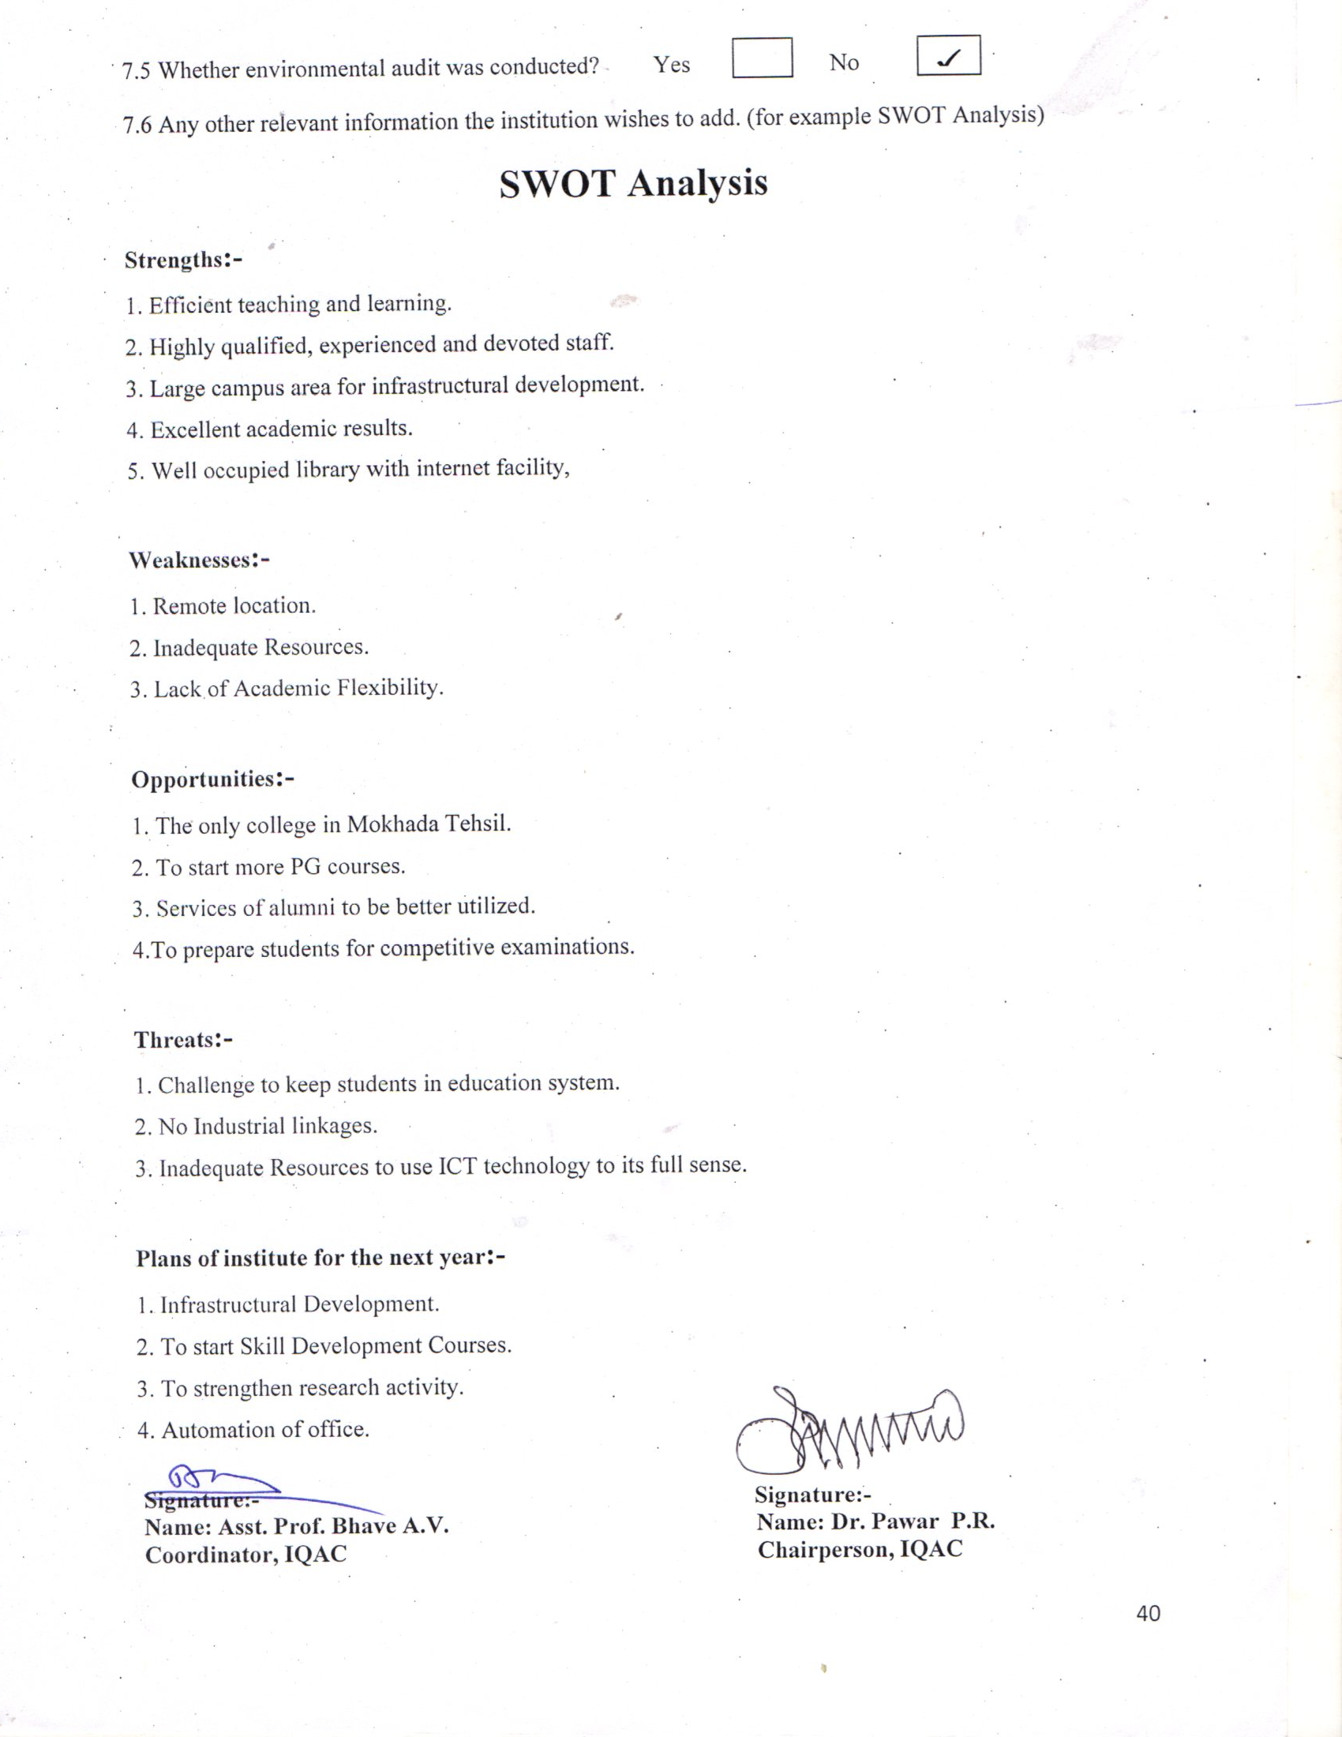

Rayat Shikshan Sanstha`s
ARTS , SCIENCE AND COMMERCE COLLLEGE, MOKHADA
Academic Calendar
Academic Year 2016-2017
First Term
(From 6th June 2016 To 25st October 2016)
Month | Week | Activity
June 2016 | 1st& 2nd Week  3rd& 4th Week | S.Y.B.A/B.Com/B.Sc Admission  T.Y. B.A/B.Com Admission  Term Meeting  Departmental Meeting s  Second and third Year Classes Commences  Submission Of Teaching Plan For first ,Third and Fifth Semester  F.Y.B.A/B.Com/B.Sc Admissions  First Year Classes Commences  Fresher`s Day  Anti-ragging Committee Meeting  Student Grievance Redressal Cell Meeting
July 2016 | 1st& 2nd Week  3rd& 4^{th Week} | M.A -1st& 2nd Admission  Filling Up Eligibility Forms  Selection of NSS Student / volunteers  Inauguration of Competition examination Centre  B.C Cell Meeting  Filling Up Scholarship and Free ship Forms  Class wise Parent- Teacher Meeting  IQAC Meeting  Youth Festival  Inauguration of Commerce ,History, Economics , Literary Association  Local Managing Committee Meeting  Sexual Harassment Committee Meeting
August 2016 | 1st Week  2nd& 3rd Week | Tree Plantation  Staff Academy Lecture  Independence Day- Flag Hosting (15th August)  Inauguration of Wallpaper Exhibition
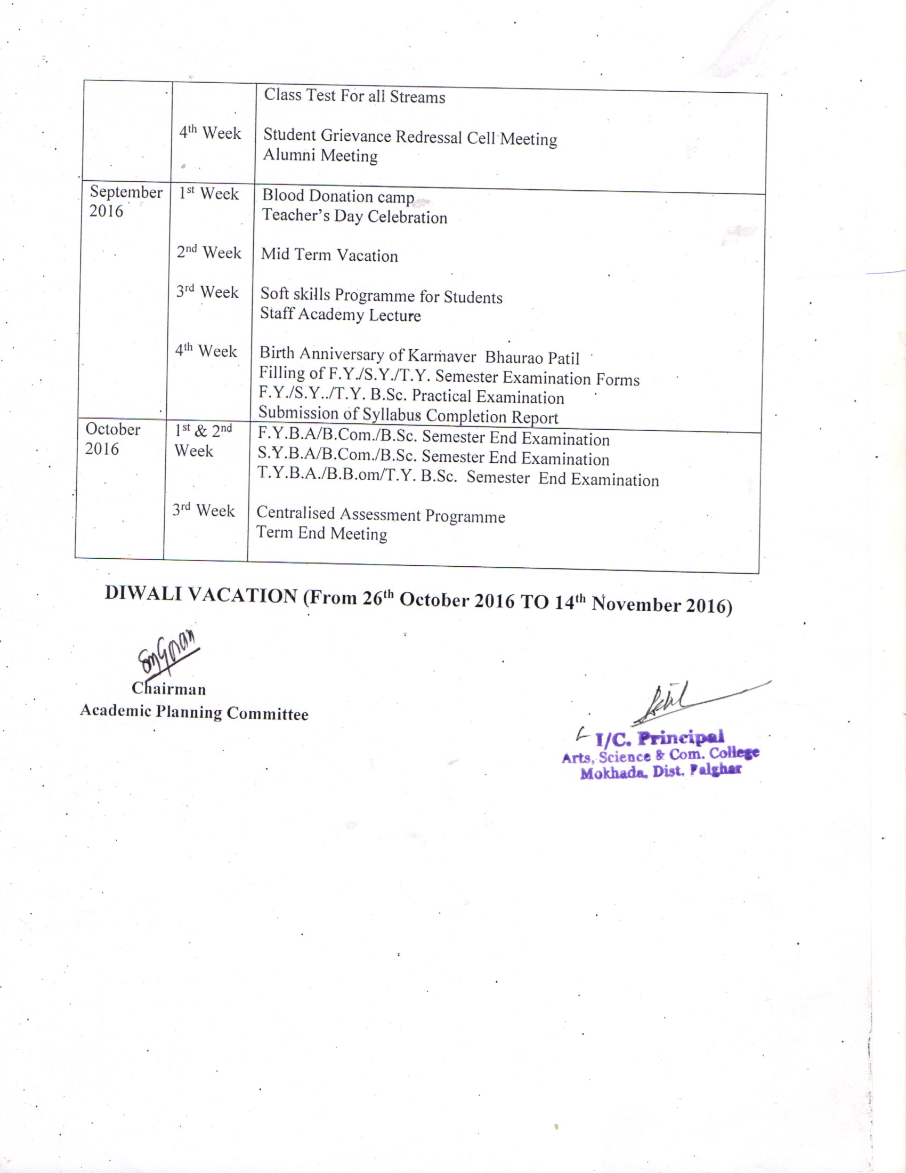

Rayat Shikshan Sanstha`s
ARTS, SCIENCE AND COMMERCE COLLLEGE, MOKHADA
Academic Calendar
Academic Year 2016-2017
Second Term
(From 15th November 2016 To 30th April 2017)
Month | Week | Activity
November 2016 | 3rd& 4th Week | Term Meeting  Submission of teaching Plan for Second, Fourth and sixth Semester  Alumni Meet/ Parents meet  Staff Academy Lecture  Departmental Meetings  Students Grievance Redressal Cell Meeting
December 2016 | 1st& 2nd Week  3rd Week  4th Week | NSS Winter Camp  Anti-Ragging Committee Meeting  Class wise Parent- teacher Meeting  First and Third Semester ATKT Examination  Education tours  Alumni Meeting  Winter Vacation
January 2017 | 1st& 2nd Week  3rd& 4th Week | Traditional Day  Class Test  Sexual Harassment Committee Meeting  Sport Competition  Flag Hosting (26th Jan.)
February 2017 | 1st& 2nd Week  3rd& 4th Week | Annual Prize Distribution  Disaster Management Workshop  Staff Academic Lecture  Literary Association Workshop  Commerce Association Workshop  F.Y/S.Y & B.Sc. Practical Examination  Submission of Syllabus Completion Report  Local Managing Committee Meeting
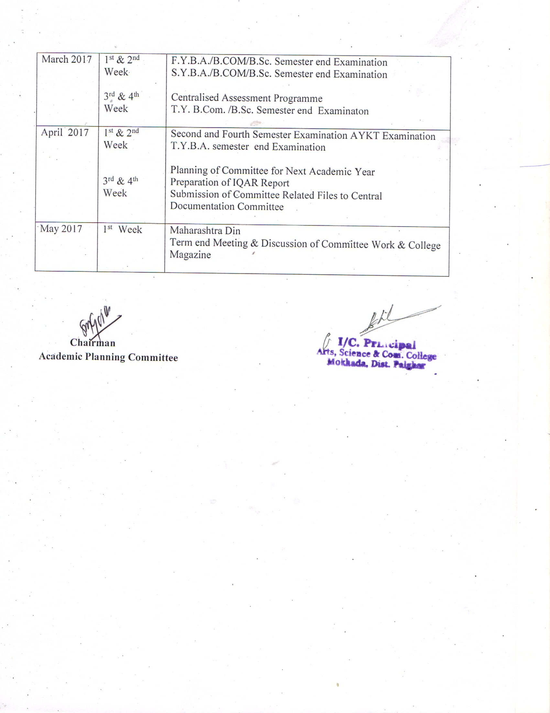

AnnexureII:-
Best practice I:
1. Title of the Practice
Teacher-Parent Scheme
The college has Teacher –parent scheme, for mentoring. The teacher works as mentor of the students. All the students of the college are covered under this scheme. The scheme is for monitoring academic development of students and for solving their problems regarding teaching and administration, counselling regarding the personal problems.
2. Goal:
The Practice ‘Mentoring student’ was introduced with an aim to resolve the problems of the students.
3. The context
Student coming to the college is from rural, tribal background and hesitate to express their various difficulties.
4. The practice.
The college implements the scheme through the Teacher-parent committee. Committee allocates the around 50 students to each teacher. The teacher arranges 4-meetings in a academic year. The detail profile of the students such as academic information and family background is maintained with the teacher.Through the meetings students can express his problems regarding academic, personal etc with the teacher. The student can also sought the guidance and help from the teacher at any time. Teacher in consultation with teacher-parent committee and principal of the college try to resolve the problems.
5. Evidence of success:
The mentoring of the students in college found useful. The students became more comfortable with the parent teacher, and expresses their problems such as :-
1. The understanding the subject concepts.
2. The library and office.
3. Financial difficulties.
4. Infrastructure related problem.
5. Personal problems.
These problems were solved by the teacher, in consultation with teacher-parent committee and Principal.
6. The difficulties encountered and resource required:
In the beginning, students did not express, communicate to the mentor teachers. So there was a need for motivation to student to express their difficulties.

Annexure III:-
Best practice II:
1. Title of the practice:
Notebook Donation Scheme
2. Goal:
Tohelp the students of poor and weakersections of the society with materials in the form of notebooks.
3. The Context:
As a part of social commitment, the students of the college give aids to the poor school children in the form of notebooks and also create the educational interest among them.
4. The practice:
The Students have some unused blank pages in their last year’s notebook. Also the college department has some stationary containing the unused blank pages. The college student collects all the blank pages together to form a notebook. Such notebooks were circulated among the school children for their rough class work. Also the new notebooks along with these recycled notebooks were given.
5. Evidence of success
During the last year 400 notebooks of 100 pages were circulated .200 students were benefited from this scheme. Apart from this, the institution has succeeded in inculcating the habit of social commitment, creating environmental awareness in the student of the college.
6.Problems Encountered and Resources Required
The institution does not encounter any problem for implementing this unique practice.

